Project Notes

1. Groups
   1. 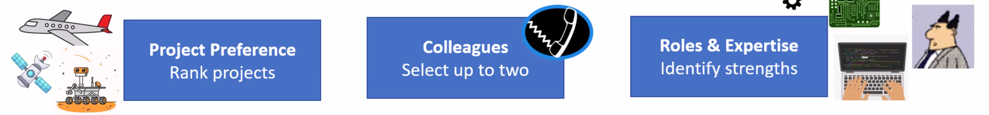
   2. 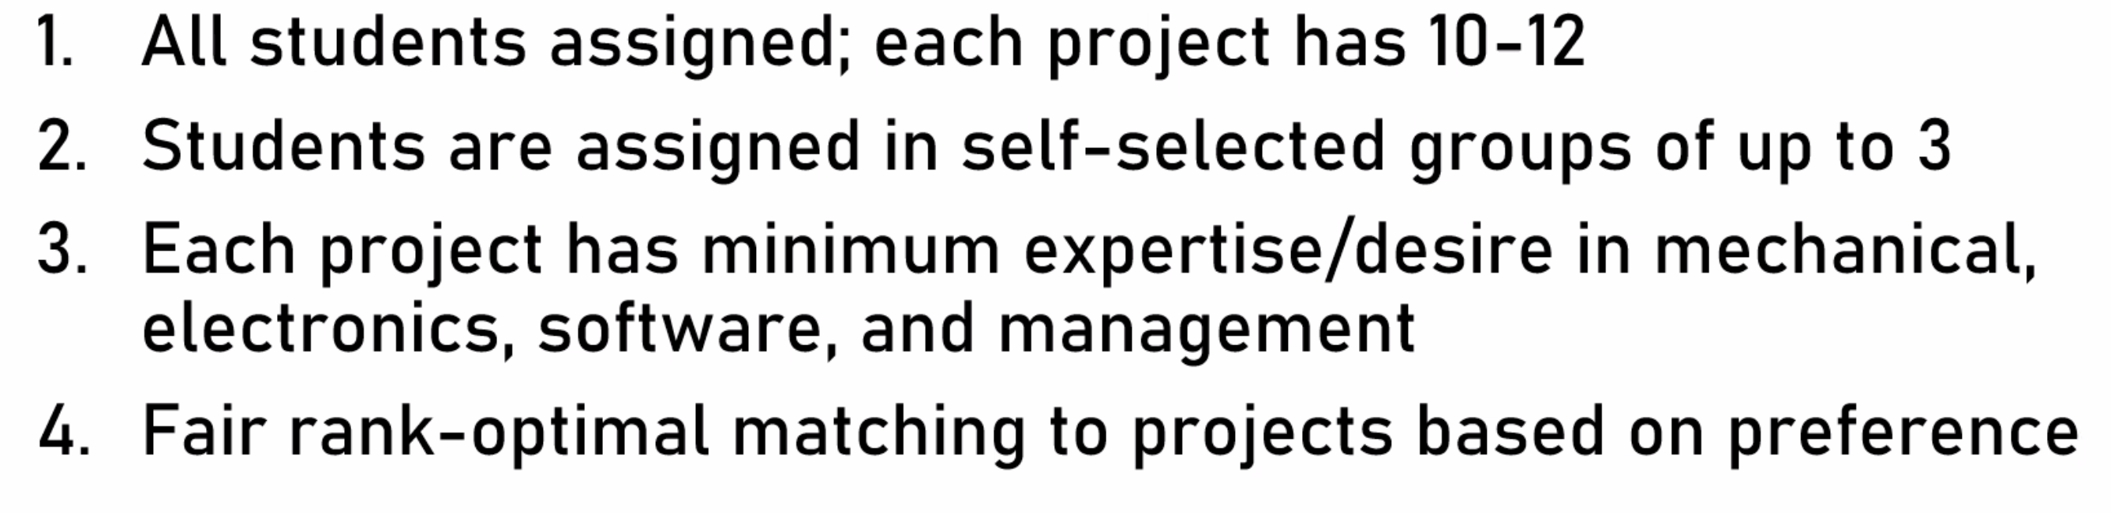
2. Project proposals
   1. CU: HERD-CU
      1. Automated flight software for
         1. Maximize endurance
         2. Maximum coverage
         3. User-friendly or generalized flight operations / mission planning
      2. 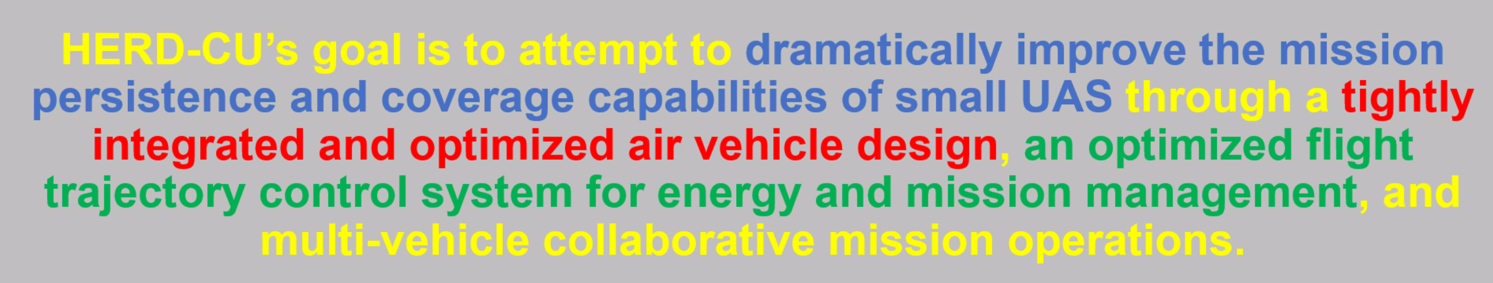
      3. Focus on green
      4. Work with first section – making hardware
      5. 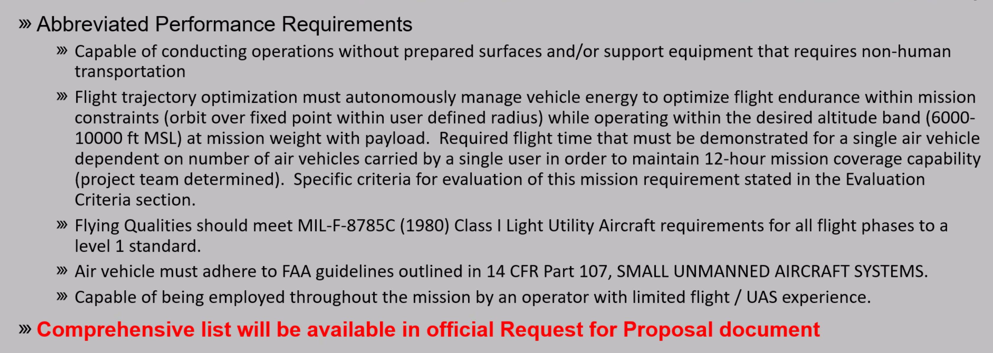
      6. Ideas
         1. Use wind to help endurance, mechanism for changing wing orientation to use wind advantageously towards positional goals
            1. Need gyroscopic wind direction sensor
         2. Start with COTS software
         3. uh
   2. Ball: NanoSAM-III
      1. Take high resolution profiles of aerosols (dust) in the stratosphere
      2. For atmospheric modelling purposes
      3. 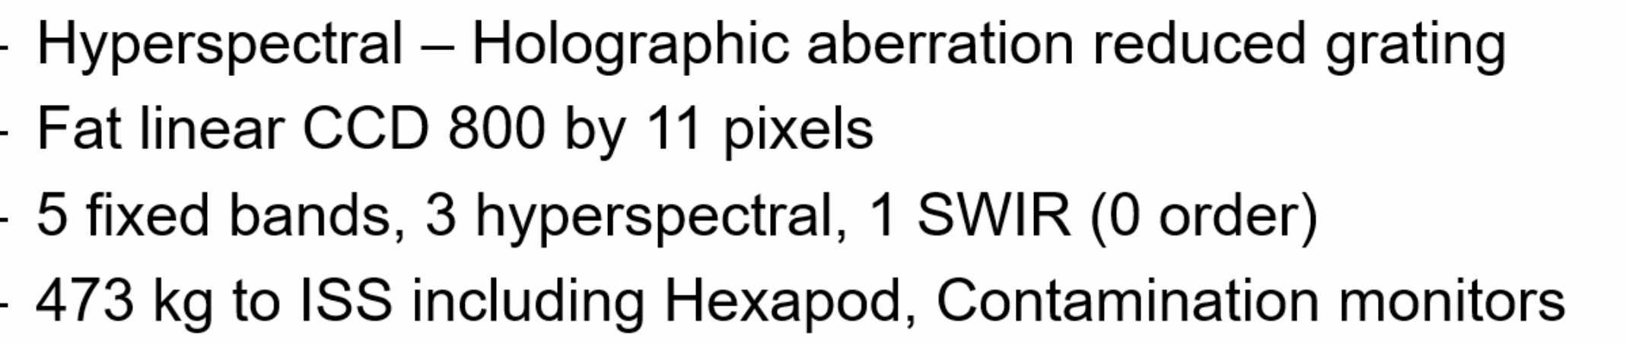
      4. 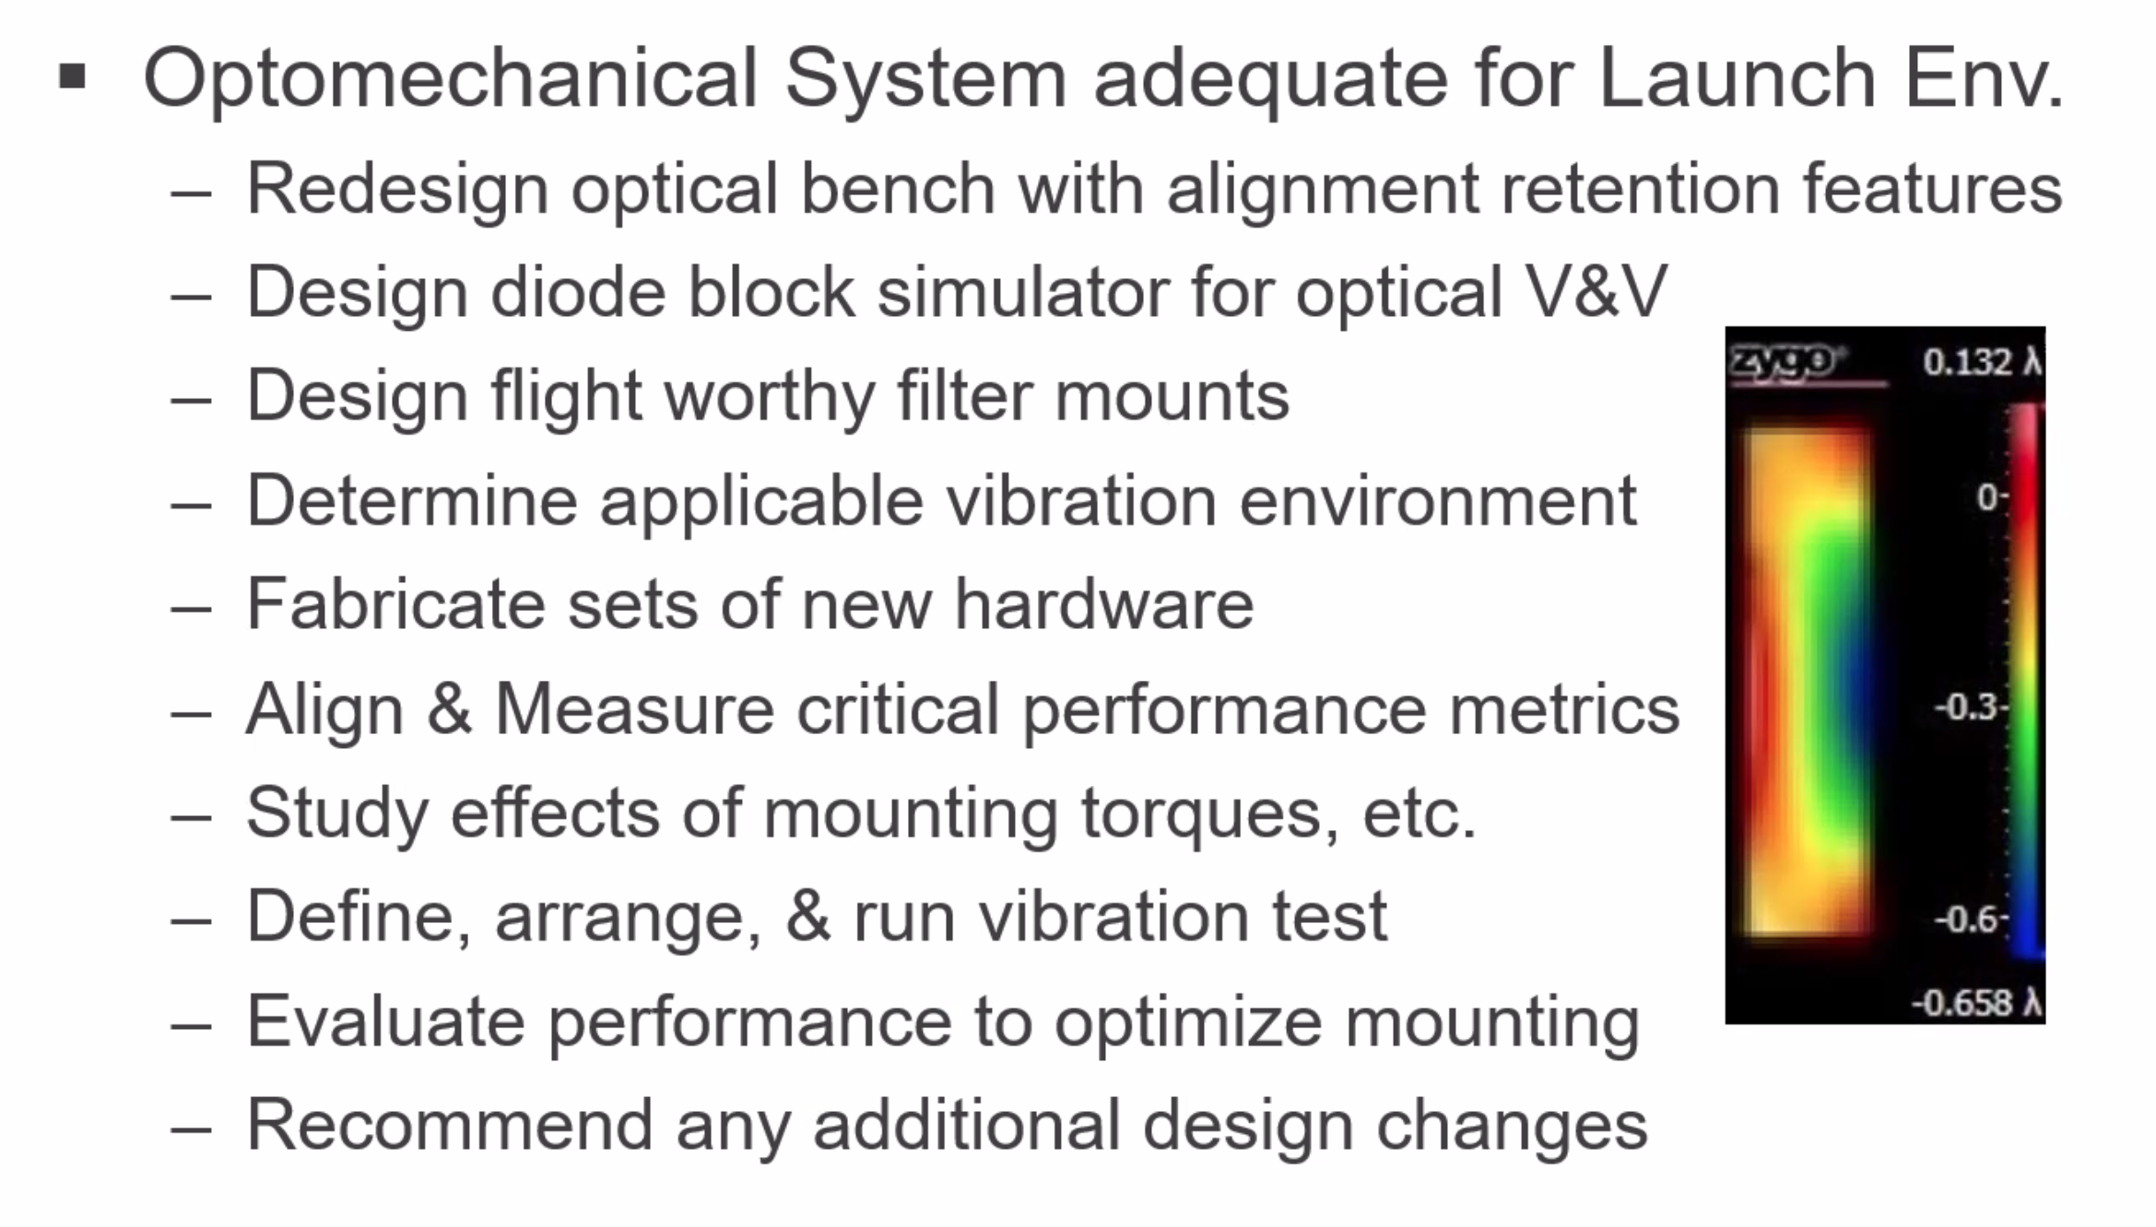
      5. Goals
         1. 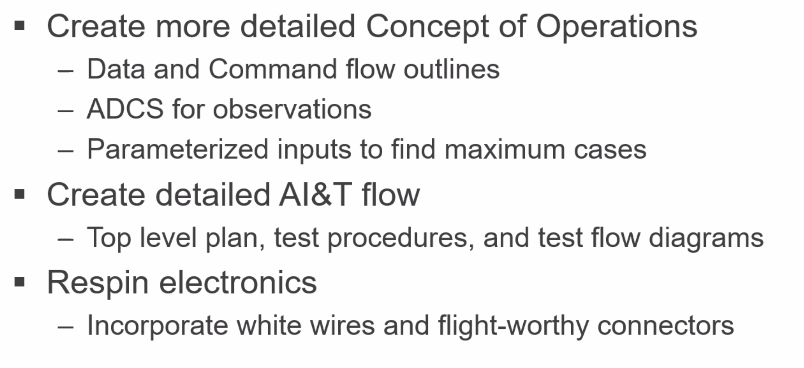
      6. Stretch goals
         1. 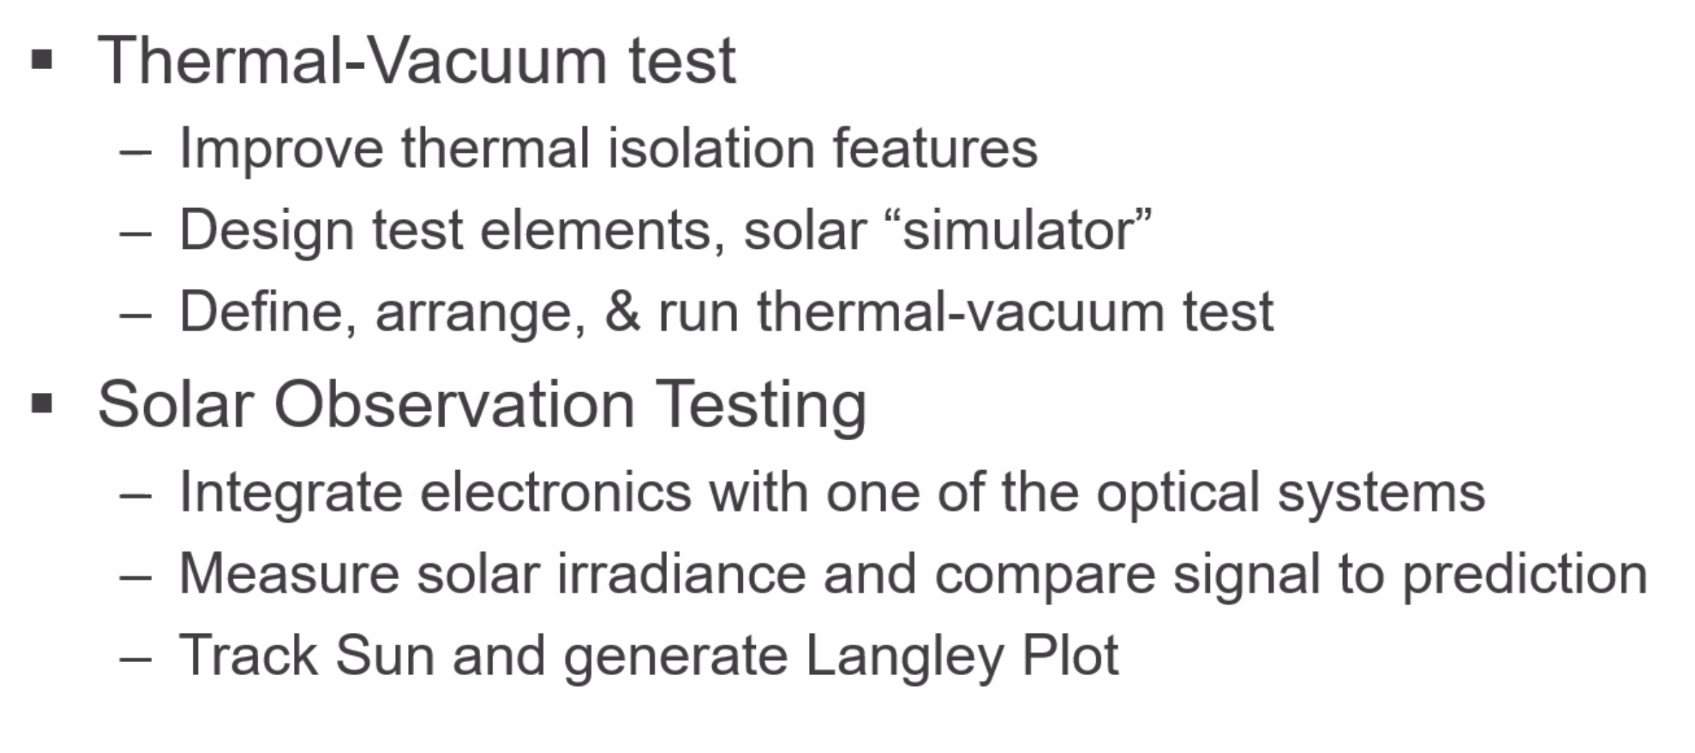
      7. Ideas
         1. Use ball facilities for design and test
   3. JPL: Sample Return – Child Rover Collector
      1. Sample housing: 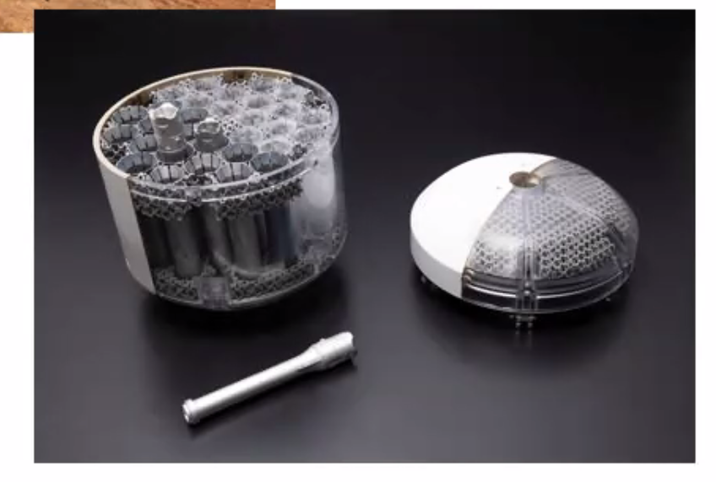
      2. Build small rover
         1. Rover collects, stores, and returns samples
      3. Mission requirements
         1. 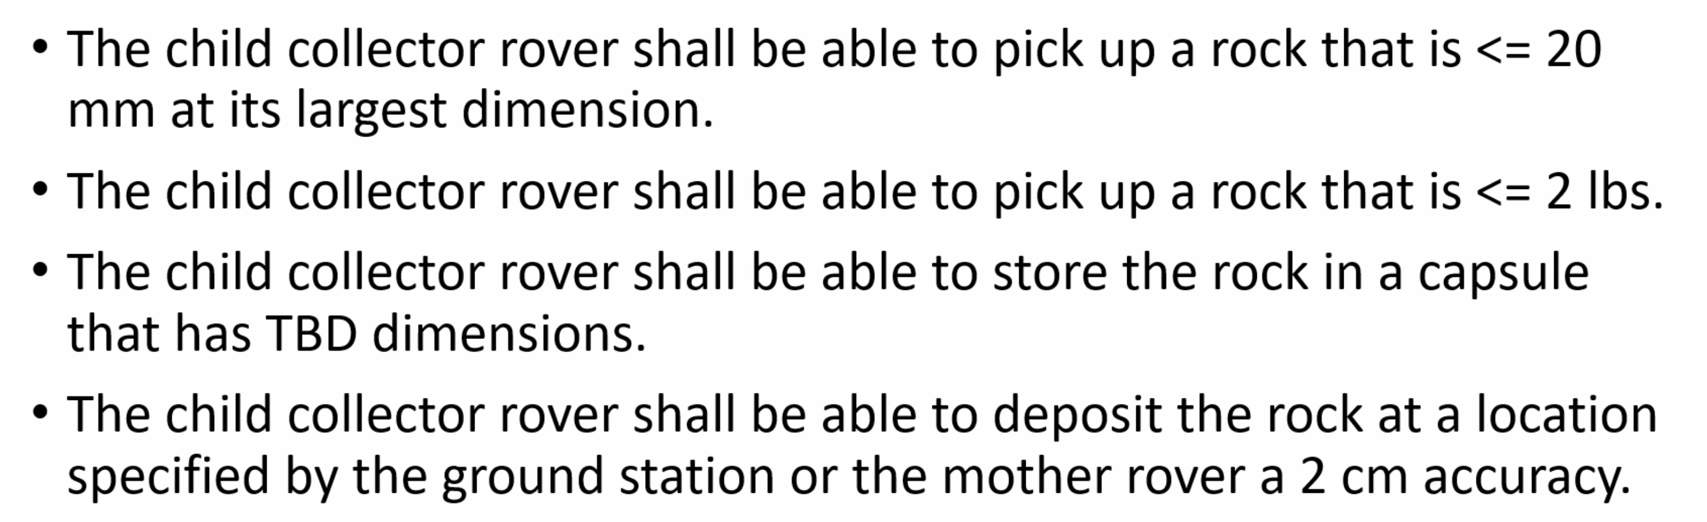
      4. Deliverables
         1. 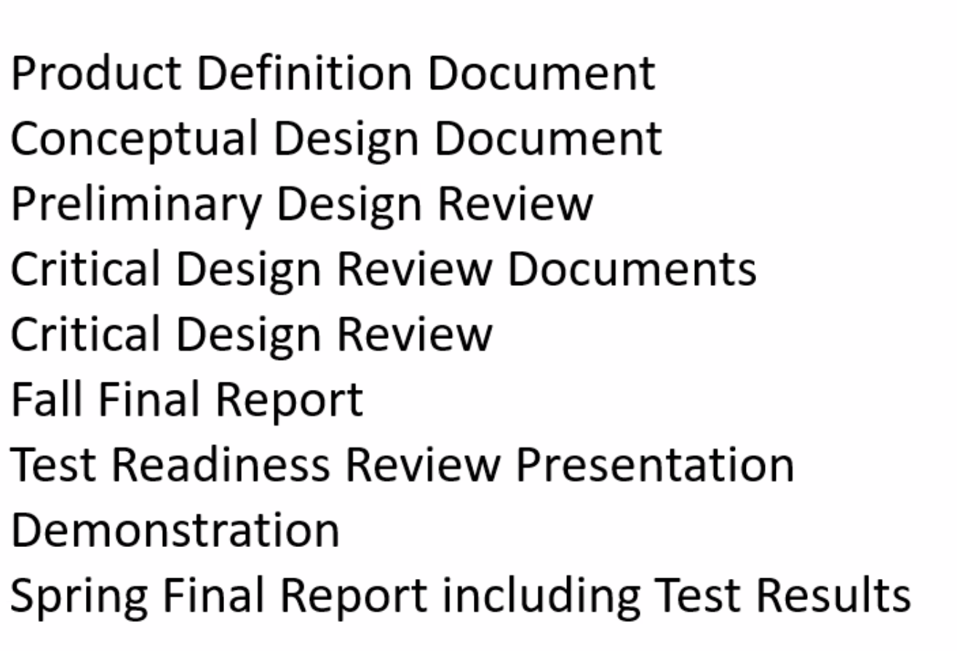
         2. 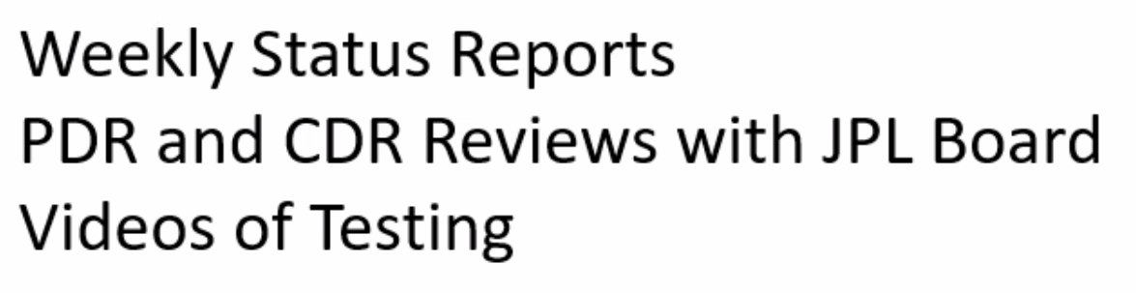
   4. SNC: Remote scene modelling for spaceborne robotic systems
      1. LEO environment
      2. Robotic tasks
         1. Cleaning
         2. Maintenance
         3. Cargo
         4. Situational awareness
         5. Waste
      3. Mission requirements
         1. 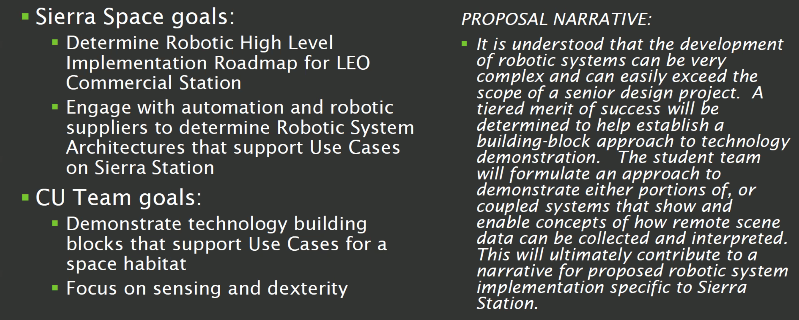
         2. 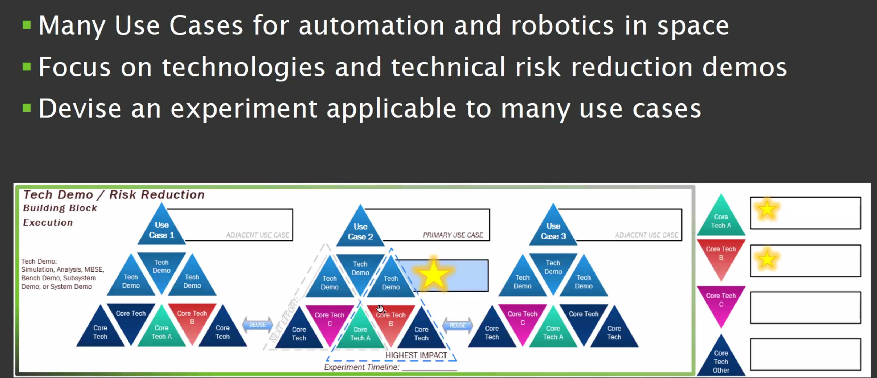
         3. 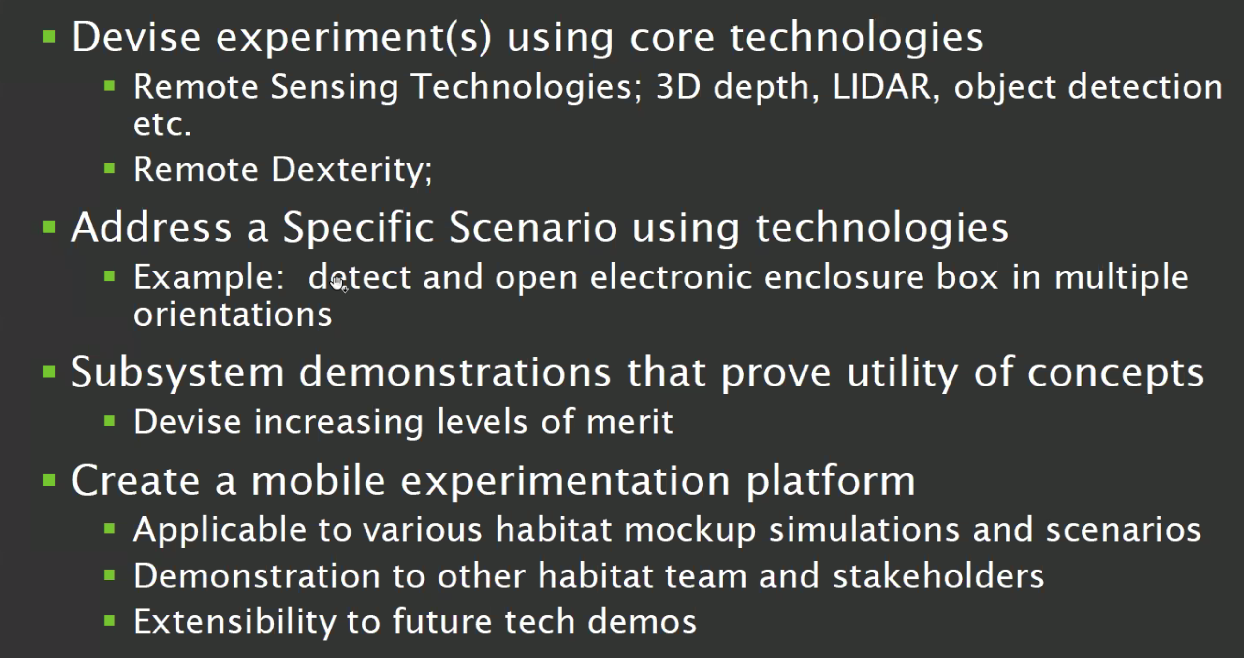
      4. Requirements
         1. 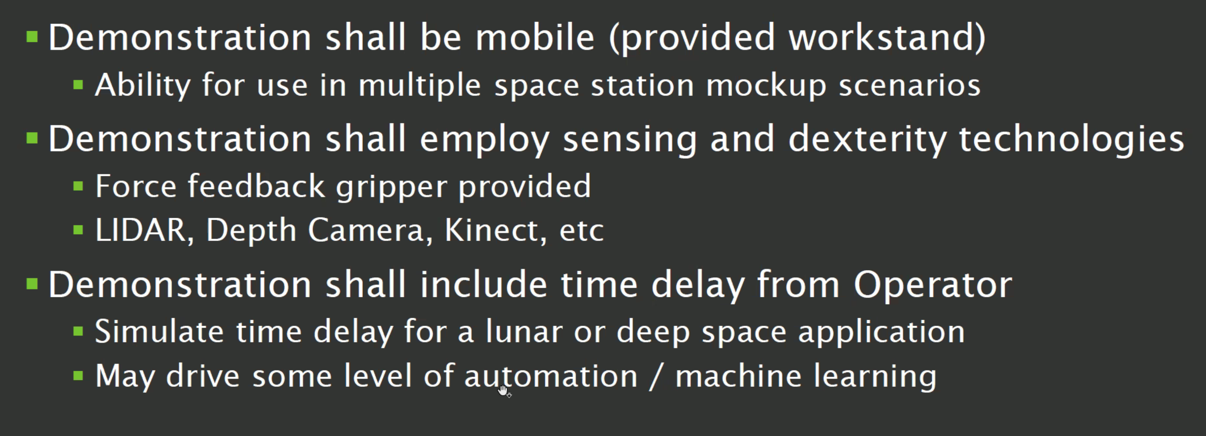
      5. Ideas
         1. Integrate computer vision plant growing apps with robotics for automated farming
         2. Capability for automated tool change: gripper, scissors, magnet...
         3. Decision tree of how to interact with surroundings
         4. Look into arms and cameras from HIRO lab
         5. 3d modelling of environment
3. 8/24/21
   1. 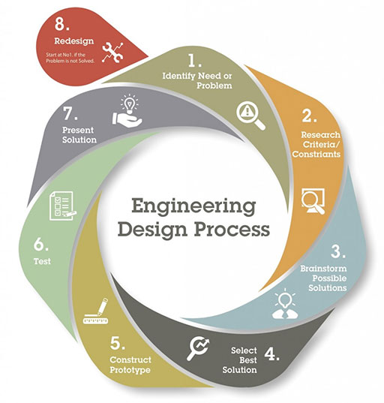
   2. 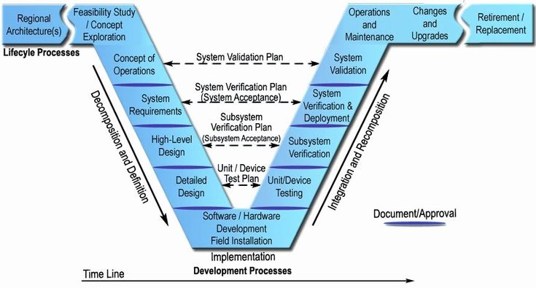
   3. Can fundraise for more money
4. 8/25/21
   1. IDK: Space flight tethered balance
      1. 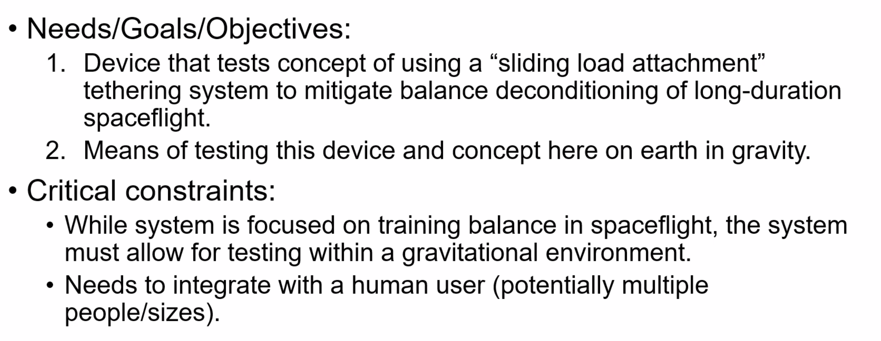
      2. Initially work in z direction only, then work on x and y: roll, pitch, and yaw
      3. Multi-purpose, create resistance training by increasing force past human weight
      4. Built-in redundancies, if something breaks, how to compensate
      5. Minimize size for fuel, cost, and space efficiency
      6. 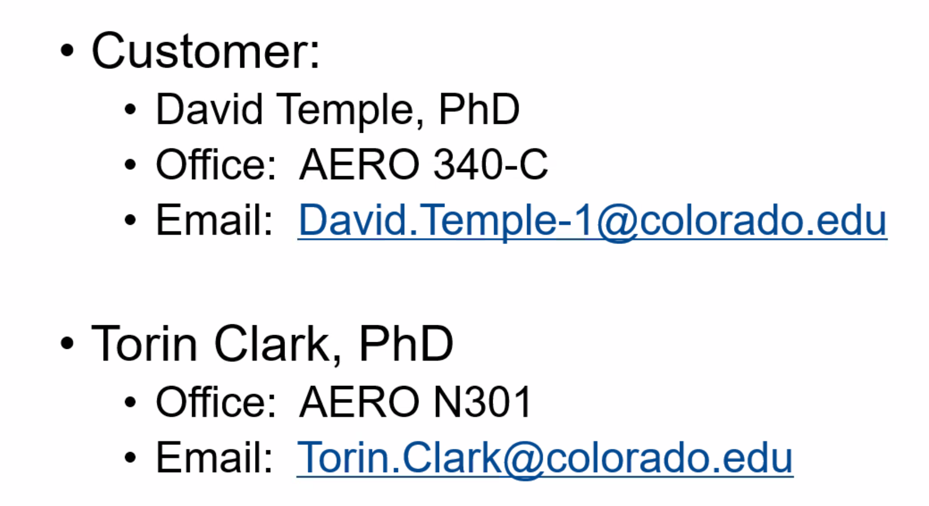
   2. EnerSys: Battery Monitoring System
      1. 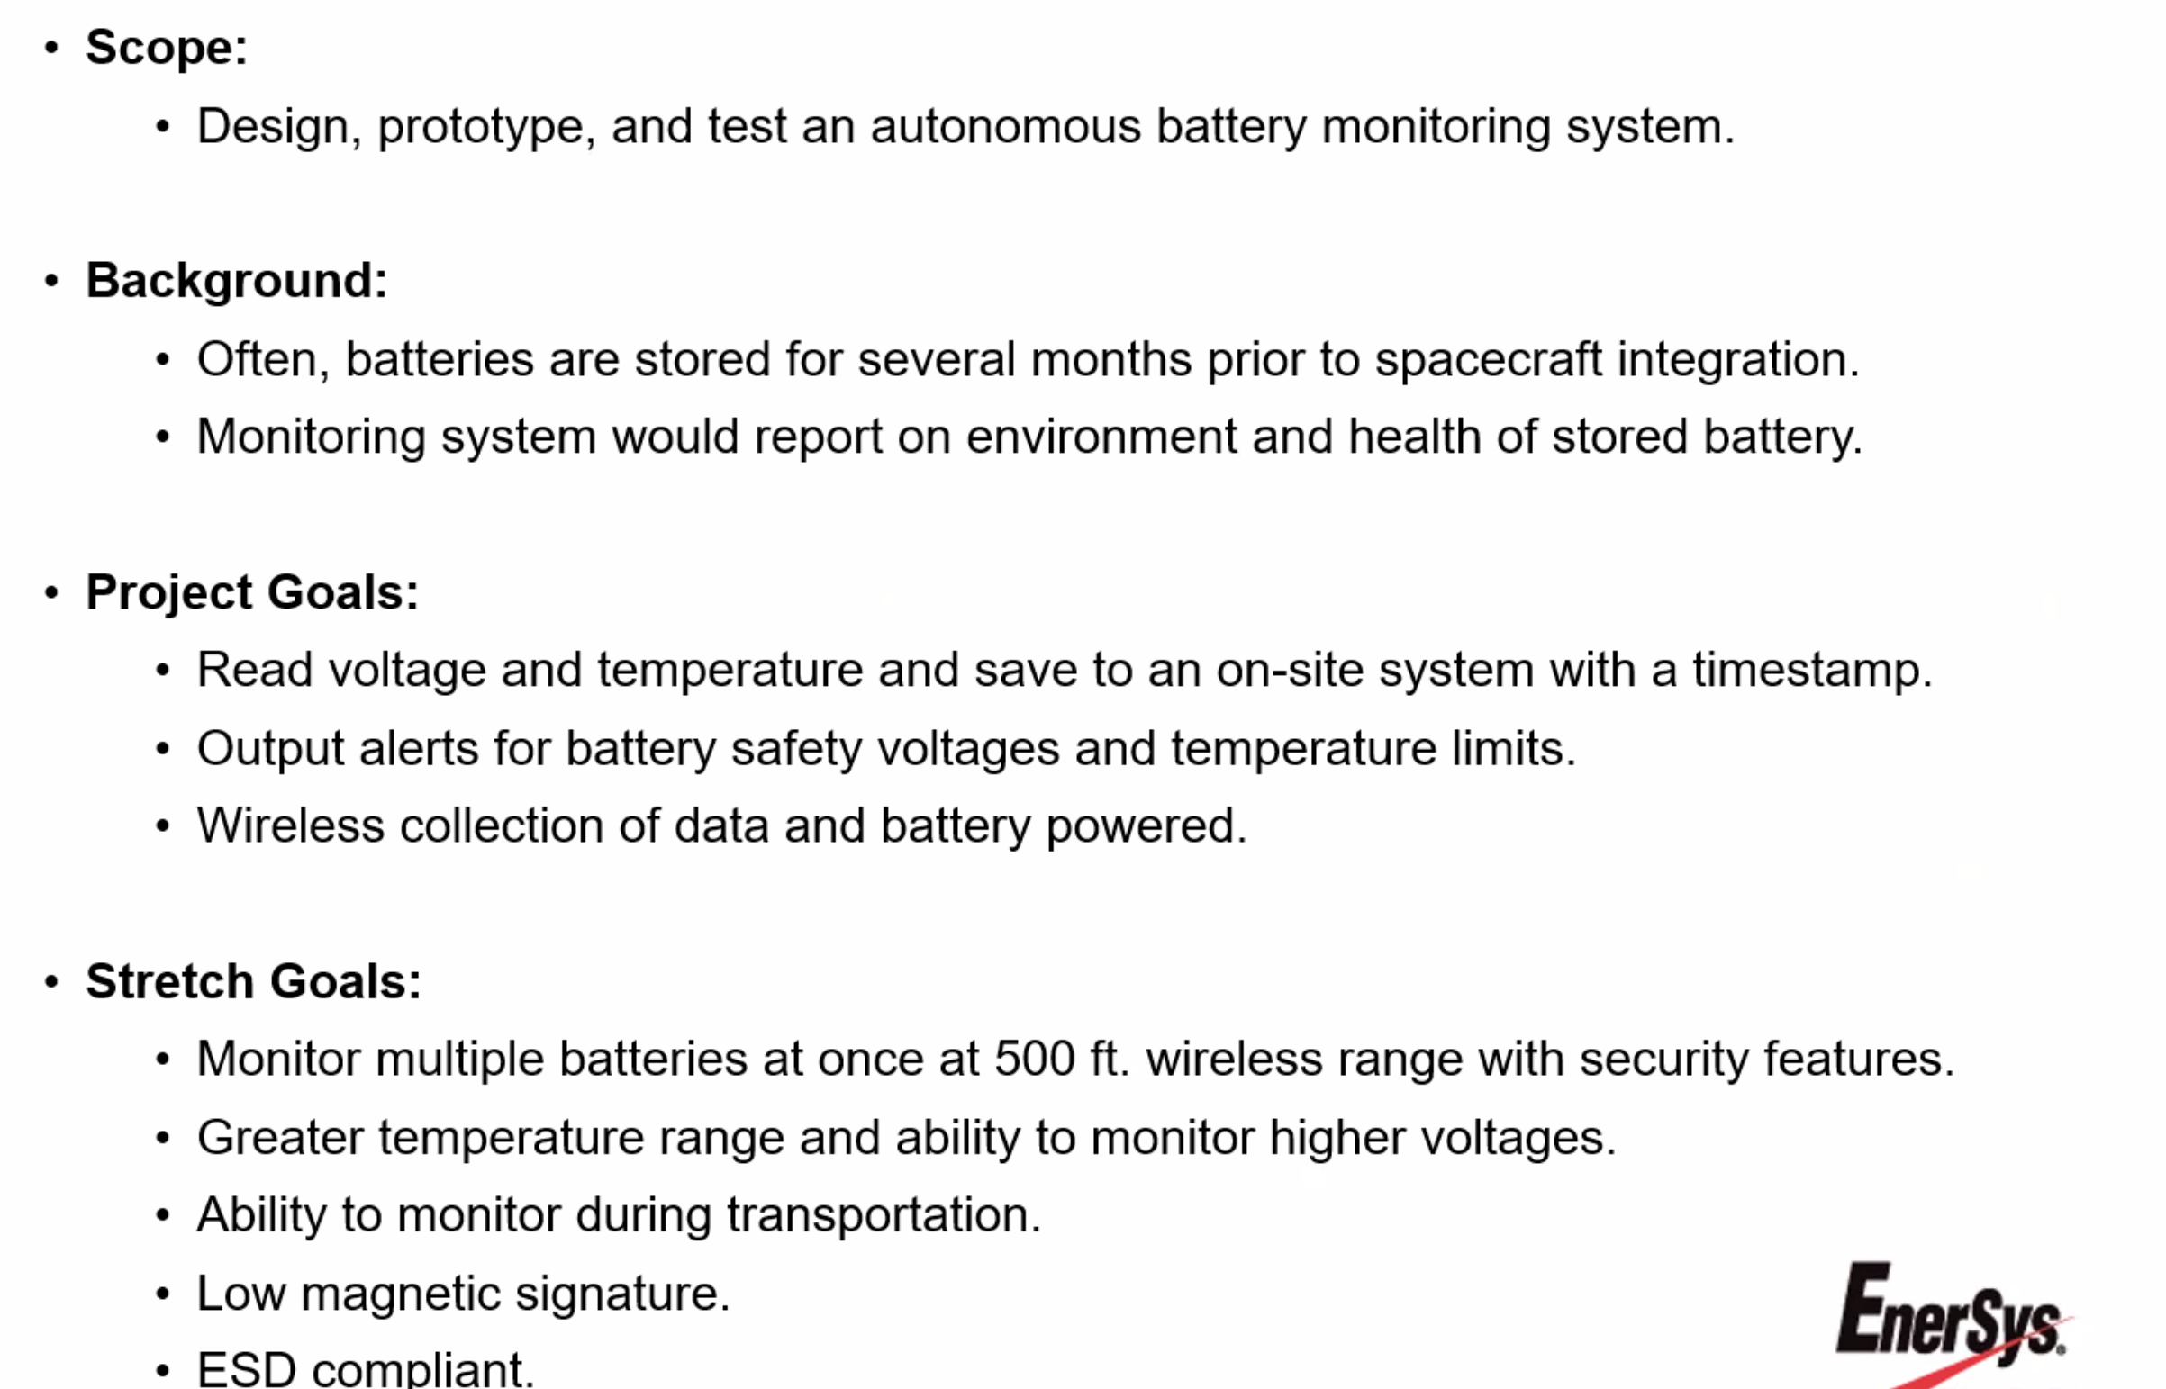
   3. Raytheon: Reconfigurable, field deployable satellite simulator
      1. 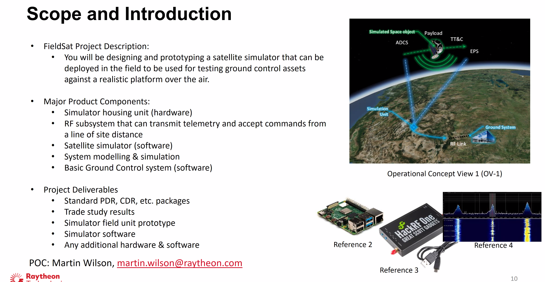
      2. 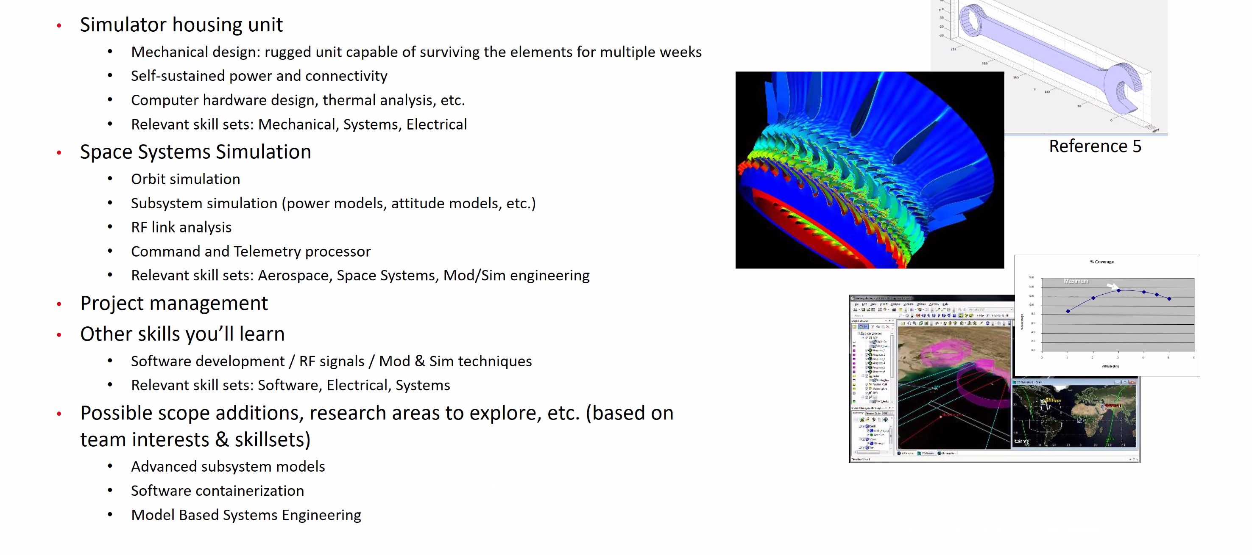
   4. Molon Labe Aircraft Seating: UAV power pod
      1. Pod charged on pad, picked up and dropped off by uav
      2. Automated pick up and drop off
      3. Modular for replaceable batteries
      4. Contain battery and cargo
      5. Durable, scalable, secure
      6. 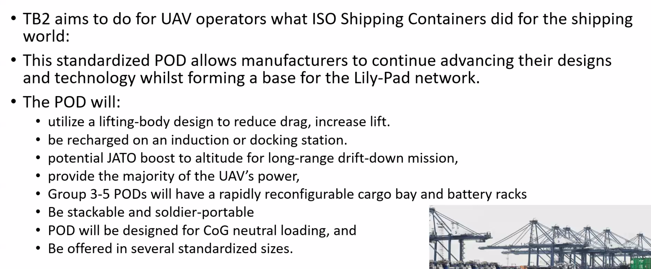
      7. 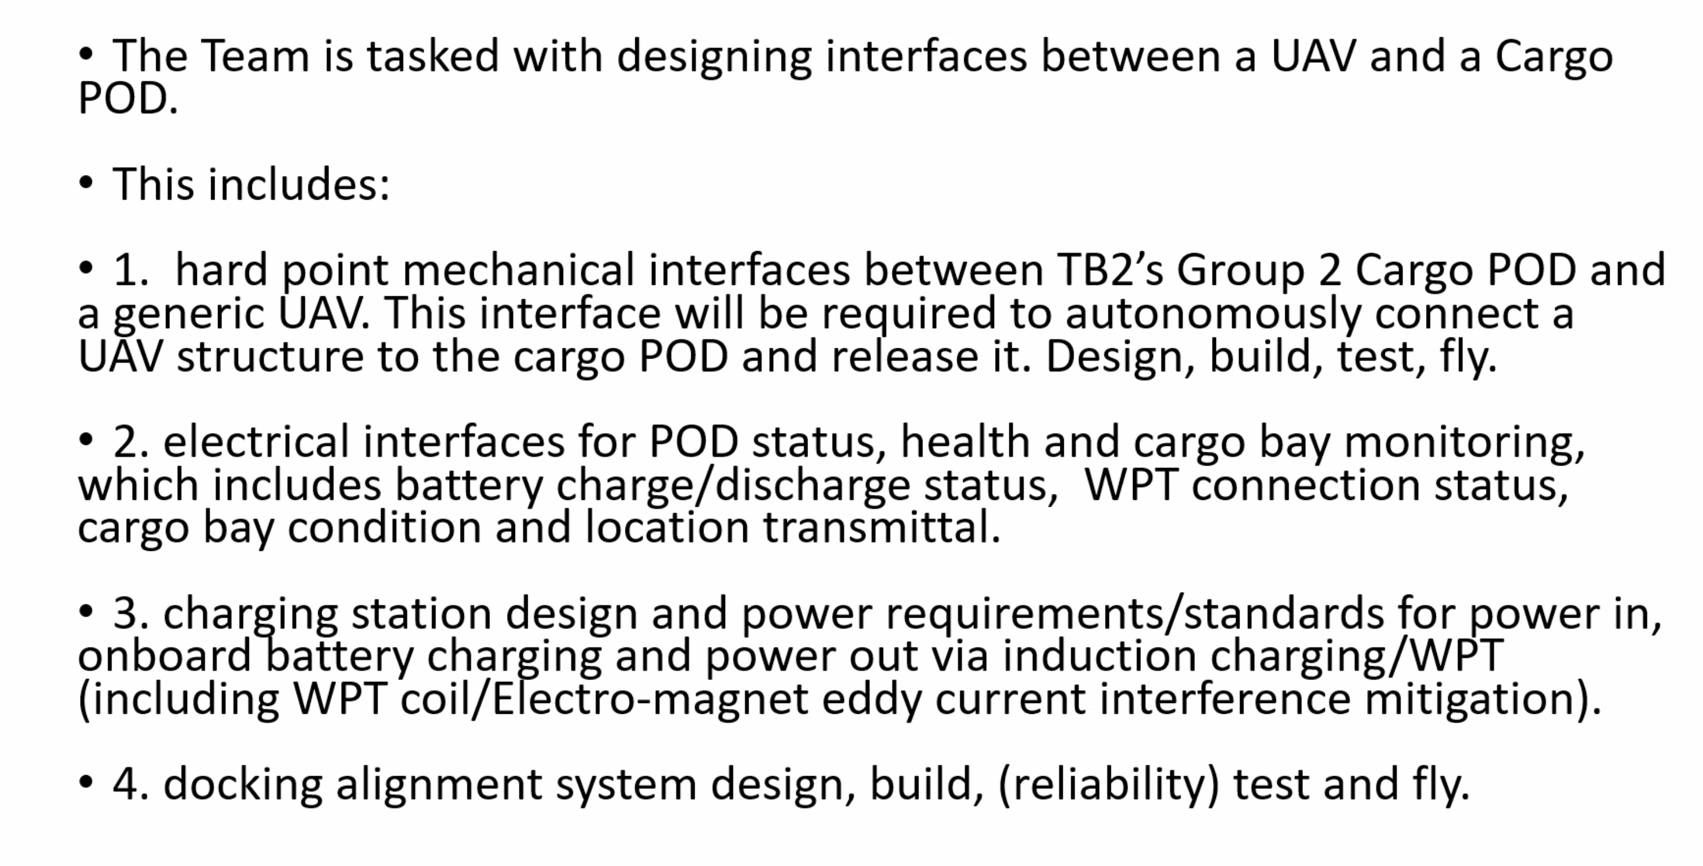
      8. 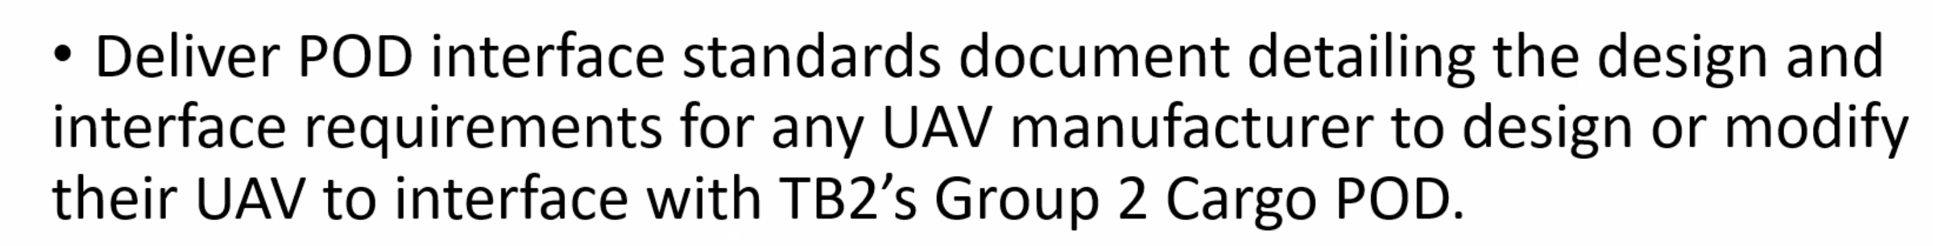
   5. Nordic: Ski Jump Simulator
      1. 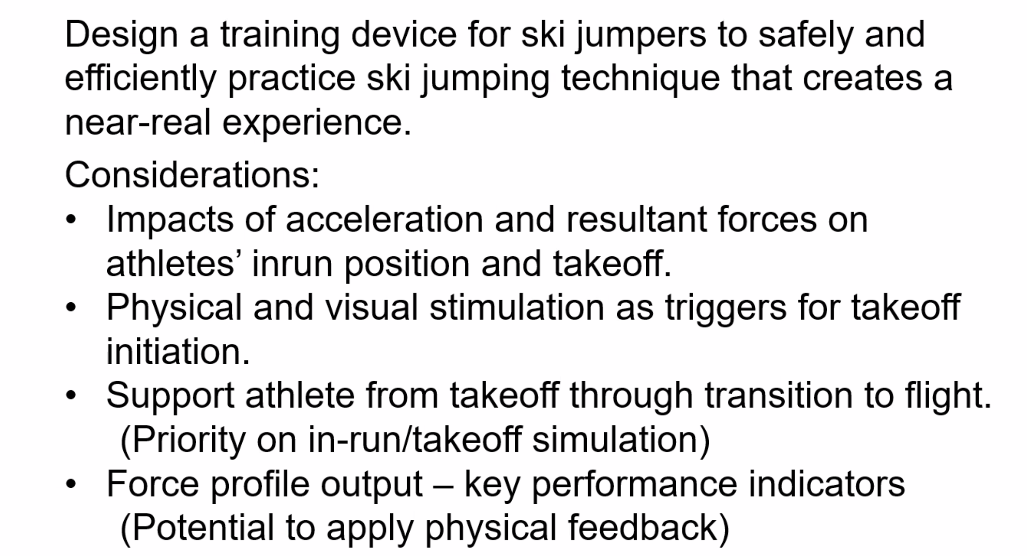
      2. 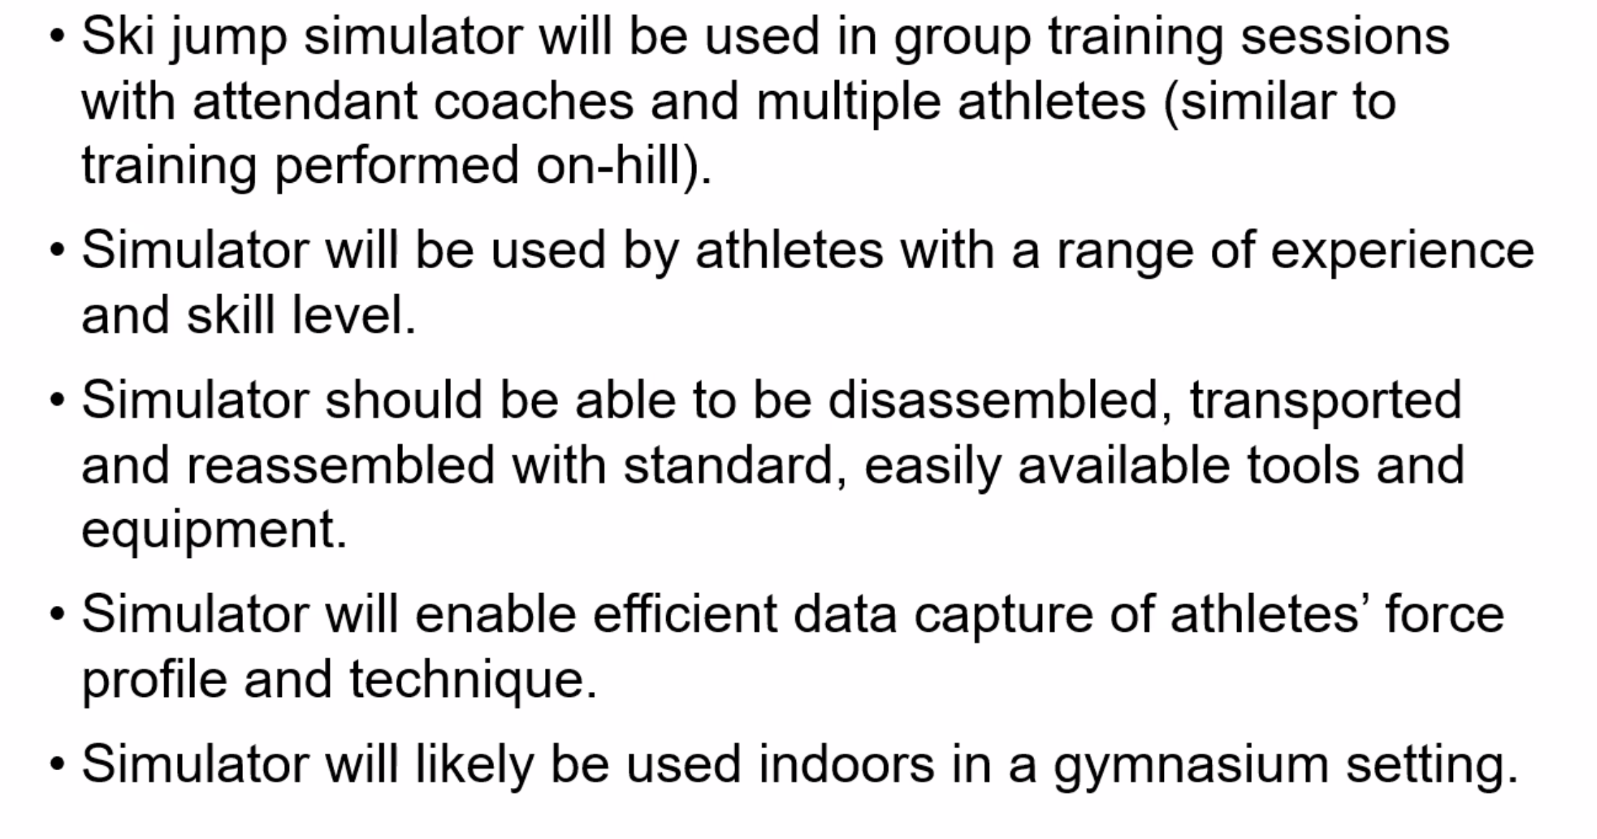
      3. Ideas
         1. Measure force and direction of takeoff (gyro)
         2. Record aerodynamics of body before, during, and after takeoff
         3. Simulate wind and snow feel (fan and treadmill?)
         4. Simulate Gs at takeoff with harness
         5. Figure out how to transfer from treadmill to gyro sensor
         6. VR type deal
         7. Lift skier off ground after takeoff
   6. Rank
      1. Nordic: Ski Jump
      2. SNC: Robotic Arm
      3. Molon: UAV Bat Box
      4. Raytheon: Sat Sim
      5. Ball: NanoSam
      6. CU: UAV Endurance
      7. JPL: Sample Return
      8. IDK: Tether Balance
      9. EnerSys: Battery Monitoring
5. 8/31/21
   1. Rocket Science Design
      1. Define what the solution must do functionally - PDD
      2. Make feasible design alternatives - CDD
         1. Trade study between alternatives
      3. Predict performance, cost, and schedule based on quantitative models and data – PDR/CDR
      4. Construct prototype
         1. Test relative to functional requirements
         2. Operate in representative environment
         3. Evaluate success
   2. Systems Engineering Principles
      1. Requirements flow down
      2. Identification of critical elements/path
      3. Hierarchical sub-system architecture
      4. Trade studies
      5. Configuration management
      6. Risk management
      7. Verification and validation
   3. Engineering V
      1. Design high level, design low level, test low level, test high level
   4. Verification vs Validation
      1. Verification
         1. Product complies with requirements
         2. ‘Shall’ statements are met
         3. Proven via test, analysis, inspection, or demonstration
         4. Relates back to requirements
      2. Validation
         1. Product accomplishes goal in intended environment
         2. Meets customer expectations
         3. Proven via test, analysis, inspection, or demonstration
         4. Relates back to CONOPS
         5. Testing conducted under realistic conditions on end product (A-Z)
   5. What is a requirement
      1. Condition or capability that is necessary for the resulting system to satisfy
         1. Functional needs
         2. Constraints
         3. Performance
      2. Says what is needed, not how it will be met
         1. Doesn’t define solution
         2. Defines problem
      3. A requirement is testable, demonstrable
         1. Unambiguous
         2. Doesn’t contradict itself or other requirements
      4. Can have tbds within requirements for now
      5. How to develop requirements
         1. Make list of needs, goals, and objectives
            1. Needs: develop problem statement
            2. Goals: expectations
            3. Objectives: target levels
         2. Develop CONOPS
            1. Reference (Design reference mission) document
            2. Define mission over time

Major phases

Behavioral characteristics

* + - * 1. Describe high-level concept of how system will be used to meet expectations
        2. Operation perspective
      1. Think through mission
         1. Reveals necessary subsystem requirements
         2. Review CONOPS with sponsor to ensure NGOs are met
      2. Identify key constraints
         1. Interfaces, environment, power, regulation (FCC), safety
      3. Identify key functions
         1. Function tree/subsystem breakdown
         2. Review critical project elements
         3. Understand key performance parameters/design drivers

What is the most important thing to the customer

* + - 1. Develop functional block diagram
         1. Does not specify architecture
         2. Specifies critical subsystems and their relations/interfaces
         3. Continuously updates through CDR
      2. Review Critical Project Element
         1. Understand key performance parameters/design drivers
         2. How is success defined

1. 9/2/21
   1. CDD Assignment
      1. Project Description
         1. Define purpose, provide brief objectives, CONOPS, and functional requirements
      2. Design Requirements
         1. Describe requirements flow-down from top-level to functional
         2. Include verification and validation requirements
      3. Key Design Options Considered
         1. Define each option with what, why, how
      4. Trade Study Process and Results
         1. Define how scores are defined and why
         2. Perform trade studies on each block in FBD
      5. Selection of Baseline Design
         1. Discuss how results of trade studies were evaluated and how that led to the base design
   2. Review Project Descriptions when writing own
      1. Things to do
         1. Be definite, use active language
      2. Things to avoid
         1. ‘Relatively’ define quantitatively
2. 9/7/21
   1. Technical Presentation Fundamentals
      1. Start just under everyone’s understanding, very high level
      2. Vary from here but continuously tie it back
      3. ConOps
3. 9/9/21
   1. Predictive Modeling
   2. Manufacturing
4. 9/16/21
   1. Trade studies
      1. Steps
         1. Identify trades
         2. Identify options
         3. Establish design metrics
            1. Cost, time, size, power, reliability, maintenance, safety
         4. Establish weights
            1. Sum of weights = 1
         5. Quantify score
         6. Compute weighted scores
         7. Evaluate and assess
      2. Keep in mind
         1. Stay in scope
         2. Look at CPEs and requirements
         3. What functions are most important
         4. What risks are most important
         5. Schedule drivers, time/cost
5. 9/21/21
   1. Preliminary Design
      1. Evolve design to implement functional requirements
      2. After CDD
         1. Identify major components
         2. Derive design requirements
         3. Evolve conops to include designs
         4. Identify and focus on CPEs
      3. Presentation
         1. Brief project definition
            1. Objectives
            2. Conops
            3. FBD
         2. Describe baseline design
            1. What is it

CPEs

Quantified attributes

* + - * 1. How does it work

Key functions

Fundamental principles

* + - 1. HAVE BUTTONS AND OUTLINE
    1. Feasibility
       1. Describe CPEs (reduce how many we have)
          1. Why were they chosen
       2. Present feasibility analyses of key CPEs
          1. Place within context of design

1. 9/22/21
   1. SKADI Song
      1. SKADI-ody-ody-ody-ody-ody-ody-ody  
         Ody-ody-ody-ody-ody-ody-ody (mwah)  
         Body-ody-ody-ody-ody-ody-ody-ody (ah, ah, ah ah)  
         Ody-ody-ody-ody-ody-ody-ody  
         SKADI crazy, curvy, wavy, big jumpy, lil' space (yeah, yeah, yeah)  
         SKADI crazy, curvy, wavy, big jumpy, lil' space (mwah)  
         SKADI-ody-ody-ody-ody-ody-ody-ody  
         Ody-ody-ody-ody-ody-ody-ody
2. 9/30/21
   1. Gantt Charts
      1. 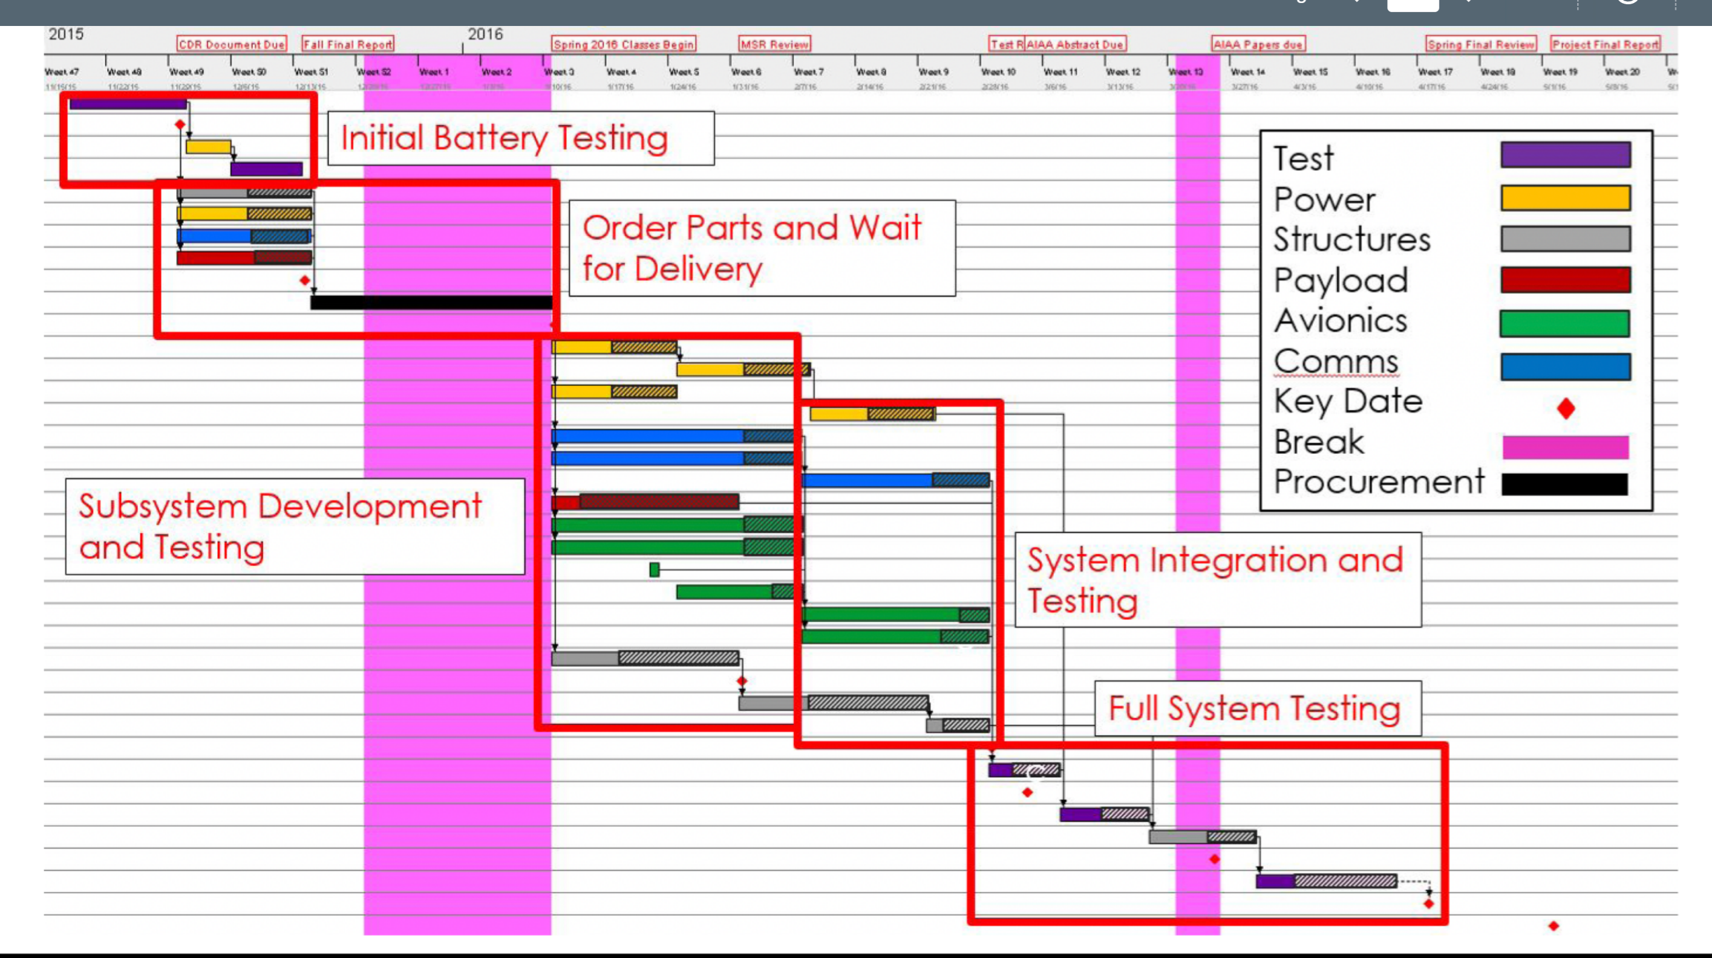
      2. Elements
         1. Task groups and tasks
         2. Milestones
         3. Dependencies
         4. Critical path
         5. Resources
         6. Margins
      3. 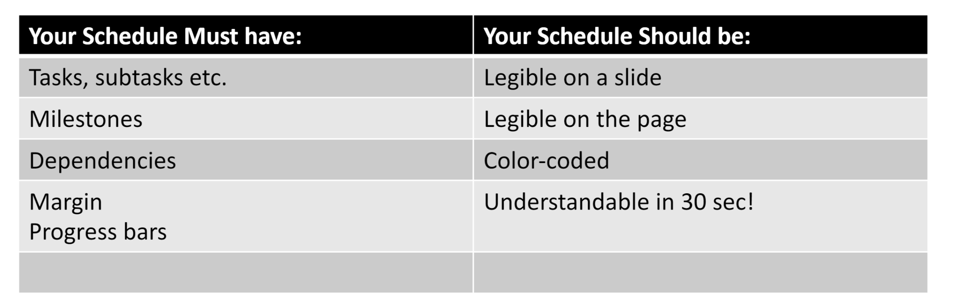
3. 10/5/21
   1. Finance
      1. Communication
         1. BE KIND
         2. Look at slides for emails
            1. Wait for updates
         3. Send emails, don’t talk to people
         4. Don’t google info, ask people
            1. Email [aerofinancehelp@colorado.edu](mailto:aerofinancehelp@colorado.edu)

First email them that you are CFO

Sign docusign

Take three classes

Send pcard to aero building, not home

Get faculty advisor or prof Jackson to approve us for early purchasing or we won’t be able to buy stuff before spring

Activate pcard

Call number on back of card

Give aero building zip 80303

Choose pin

* + - 1. Can make purchases through jackie’s amazon (tax free)
    1. Documentation
       1. Keep receipts
          1. Upload to concur
          2. Or upload receipts to google folder and it will be taken care of
          3. Don’t buy things yourself or we’ll have issues
       2. If purchasing through Jackie’s amazon – need not deal w receipt
       3. Expense tracking
          1. Excel sheet provided
          2. Show amazon expenses as well
    2. Logistics
       1. 1500 spending limit
       2. CU is tax exempt – MAKE SURE YOU DON’T PAY TAX (HEADACHE)
          1. Save tax exempt form when you get it
          2. Amazon orders must go through ticket system
          3. Ask to be tax exempt when ordering

If we accidentally pay tax, contact customer service for refund

* + - 1. Shipping / package pick up
         1. Put CFO name on deliveries
         2. Ship to aero building
         3. \*review slide for this\*
    1. Closeout
       1. All purchases done
       2. Concur fully updated
       3. \*review slide for this\*
    2. Travel funding
       1. Need more info, sit down with Laura

1. Finance Trainings
   1. Procurement, Purchasing, and Contract Management
      1. Procurement Service Center
         1. Go to them with questions if aerofinance doesn’t know
         2. P-Card
            1. Can get limit up to 5000 per transaction
            2. <https://www.cu.edu/psc/training/online-courses-related-procurement-and-travel/skillsoft-resource-pages/resources> for rules on P-card
            3. Don’t prepay
            4. Food and beverage handled in concur

Need PSC form for alcohol

* + - 1. PSC flowchart
         1. 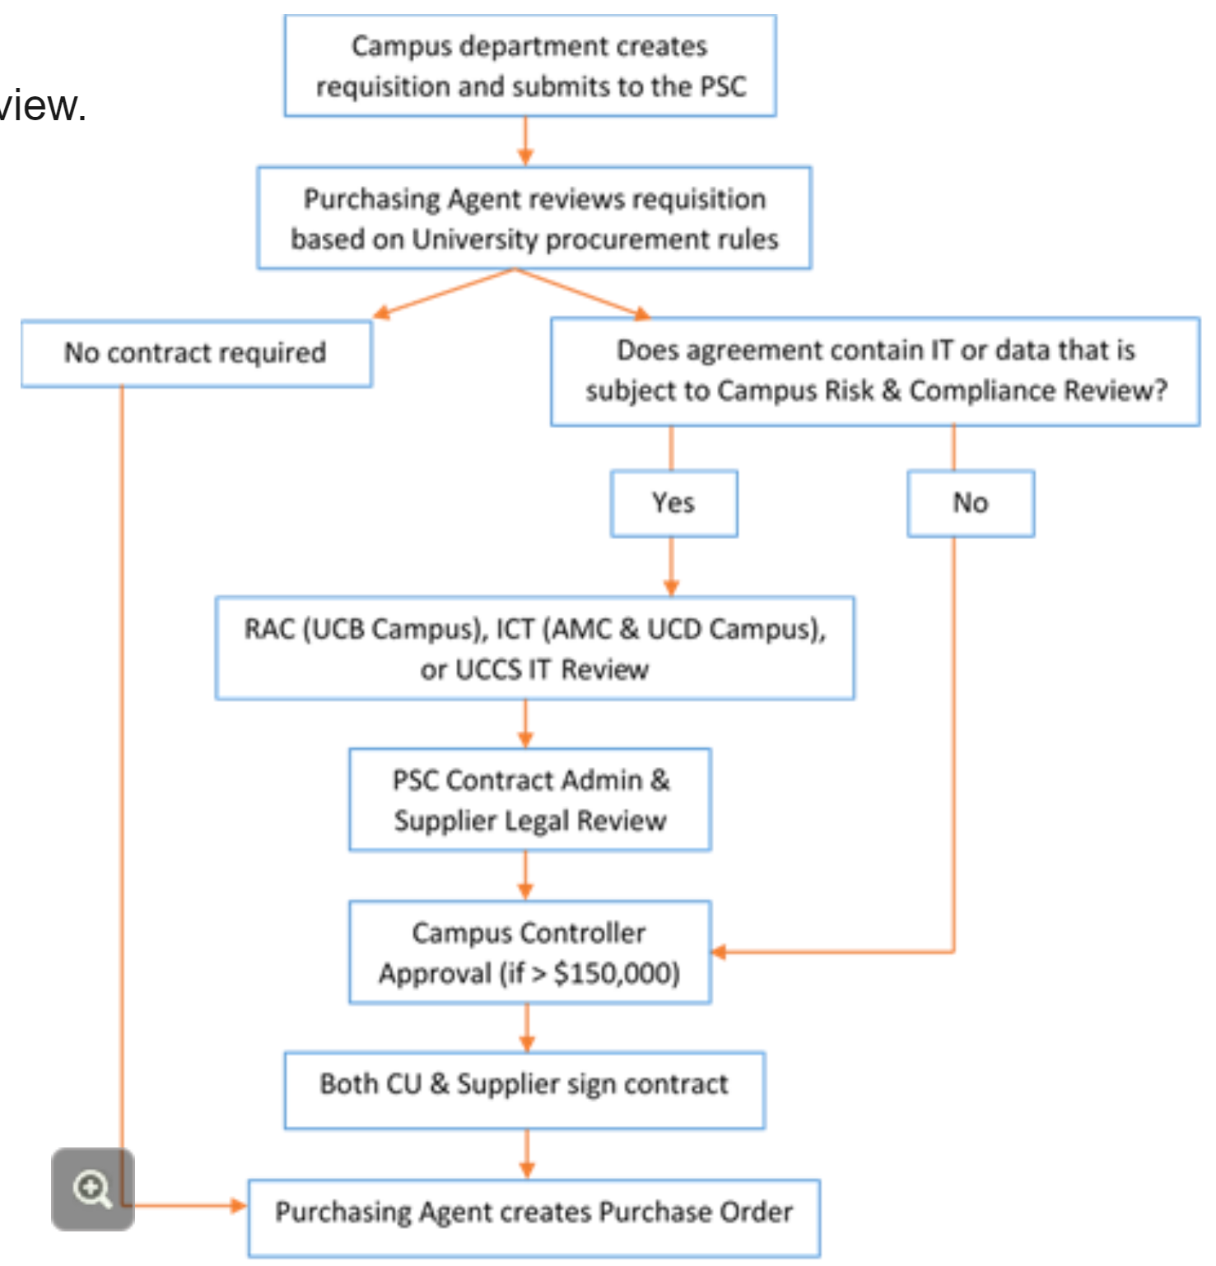
  1. Procurement Card Cardholder
     1. Logistics
        1. Single purchase limit = 5000, available exceptions up to 10000
        2. Give receipts to ‘delegate’ (aerohelp or Miv) asap
           1. Ensure its uploaded to concur
        3. Concur used for products, travel, and expenses
        4. 1 P-card expense report per month
           1. Pick a time, 2nd to last day of the month
           2. Limit is reset 20th of the month
     2. Prohibited purchases
        1. Split purchases
        2. Travel expenses
        3. Tax
        4. Parking
        5. Liquor
        6. Cash
        7. Contracts
        8. Foreign companies?
           1. Cannot buy from chin directly
           2. Any foreign purchase is +30 day delay
           3. Make sure that foreign purchase is necessary, try to figure out workaround

Aim for Japanese companies

Check if they take credit cards, that alleviates most headaches

* + - 1. Personal expense
         1. If personal expense is paid on pcard by mistake, refund to card or write check to university, tell AO
    1. Making purchases
       1. Steps
          1. Select supplier
          2. Place order

Tax exemption

University discounts

Delivery information

Request itemized list of products ordered

Descriptions

Costs

Don’t give out card information sketchily

* + - * 1. Document expenses

Expenses over $25 need itemized reports from supplier

Vendor identification

Date of purchase

Descriptions and quantities

Total cost and cost per item

Justification of purchase

Invoices or receipts should suffice

If receipts are lost or unavailable

Indicate this in concur comments

Get information from supplier

1. 10/12/21
   1. CFO stuff
      1. Jumping – talk to rafi about that – legal
      2. Travel
         1. Charge mileage for a car
            1. 54 cents a mile
            2. Can cap mileage at something
         2. Fill out travel request – whats in email
            1. If flying – need travel approved

Done through concur

Would come out of budget

Get quote from cu travel agent before reserving flights

* + - * 1. Everything comes out of budget
    1. Ordering early
       1. Get quote, copy rafi, ensure funds are available from Nordic
          1. Budget and project justification, why we need it early
       2. Get email from Nordic about extra 5k to Laura and contracting officers
    2. Extra money
       1. Need addendum to contract or new contract between Nordic and cu
  1. ACTION ITEMS
     1. Figure out if and when big ticket items are needed
        1. If needed, send info to Laura and Rafi
     2. Decide travel plan
     3. Make an at risk plan of success
     4. Make plan for monthly spending report
     5. Make plan for foreign purchase